PORT TOWNSEND SCHOOL DISTRICT #50

Skyward Employee Access

Instructions



**Contents (Use mouse to click to desired section)**

Introduction..................................................................................................................................... 3

Accessing Employee Access........................................................................................................... 3

Viewing and Printing Your Check History..................................................................................... 4

Viewing Leave Balances................................................................................................................. 7

Viewing Personal Information ........................................................................................................ 8

Viewing Address and Phone Information ................................................................................... 8

Running Payroll Reports........................................................................................................... 10

....................................................................................................................................................... 11

Using the Check Estimator ........................................................................................................... 11

Verify your W-4 information........................................................................................................ 12

Viewing and Printing W-2 ............................................................................................................ 13

Questions? ..................................................................................................................................... 14

**Best Practices**

• **Security**-***Do not share your Skyward username and password***. Employee Access displays personal information that you may want to keep confidential. If you are logged into Educator Access, your Employee Access tab will be visible.

• **Payroll Information Availability**-Monthly payroll information will be available for employees to view approximately 5 days before pay date. Deposits to bank accounts will not be made until payday itself.

• **Archiving, Monthly Payroll**-The district has not printed/distributed paper copies since December 2009. You may want to print a copy of your earnings statement each month for your paper based archives. Alternatively, you can make an electronic copy of your records as well.

• **Archiving After Separation from Employment**-If you separate from employment with the school district, your rights to Employee Access will be suspended, as well as your e- mail account and other electronic credentials. Print your year to date pay information from Employee Access prior to the suspension of your electronic credentials. A W-2 for the year in which you separate from employment will be mailed to your forwarding address when the W-2 becomes available.

**Introduction**

Skyward Employee Access Module is a web based computer application that allows users to:

1. View your check history and print pay stubs with employer information – View and print Year-to-Date history for current and prior years. This can be very useful when applying for loans or other types of financing.

2. Use the check estimator – create different withholding and benefit scenarios to see how they will impact your take-home pay amount.

3. Print your W-2’s – Creates a W-2 form that can be printed and mailed with your tax forms.

4. Check your personal information such as address or phone – Verify the information used by payroll. You may not change your data from this application.

5. Check your Calendar Year To Date payroll totals.

6. Check your Fiscal Year To Date (September 1 through August 31) payroll totals.

7. Verify your W-4 information – View your current withholding status. You may not change your data from this application but you can ask the payroll administrator how to make these changes.

8. Check your leave balance – What leave has posted against your leave balances?

Accessing Employee Access

The Port Townsend School District has a quick link to access Employee Access on the front page of its website. The URL is https://www2.wrdc.wa-k12.net/launch/bookmark-wrdc-porttownsend.html

Click on this button and you will be redirected to the SKYWARD Login screen. Enter the login and password given to you by the Human Resources office.

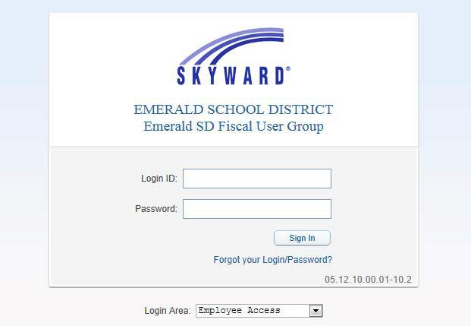

***Don’t remember your login or password? Click here.***

Once logged into SKYWARD, you may see more than Employee Access based upon your security settings. Depending on your security, you may have more or less tabs available than shown in the figure below.

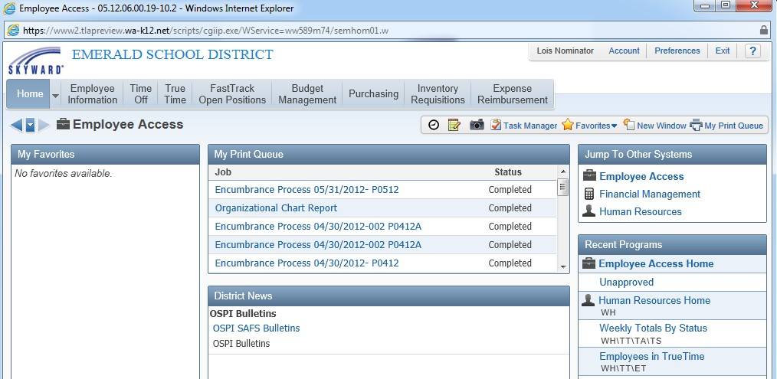

The remainder of this document describes the information available to all Staff through the

Employee Access module.

**Viewing and Printing Your Check History**

To view your check history, click on the EMPLOYEE INFORMATION tab then in the

PAYROLL field click on CHECK HISTORY.

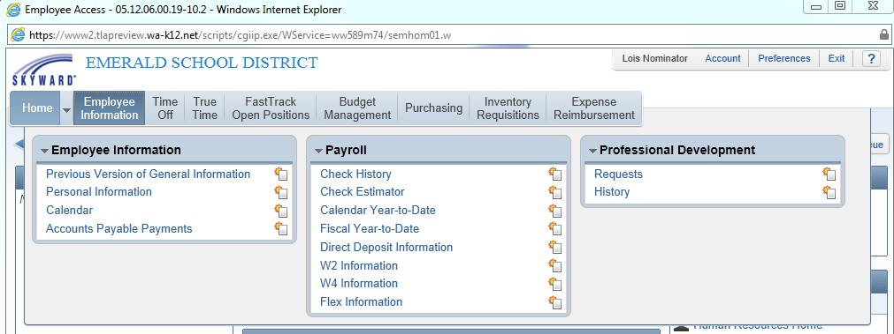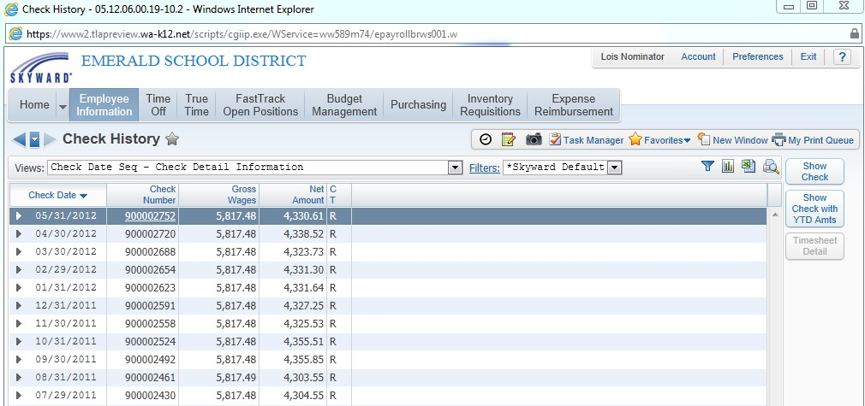

Your check information will be listed from the latest to the earliest.

Clicking on the underlined check number will bring up your payroll information for that month. This information will be available to you until you leave the district.

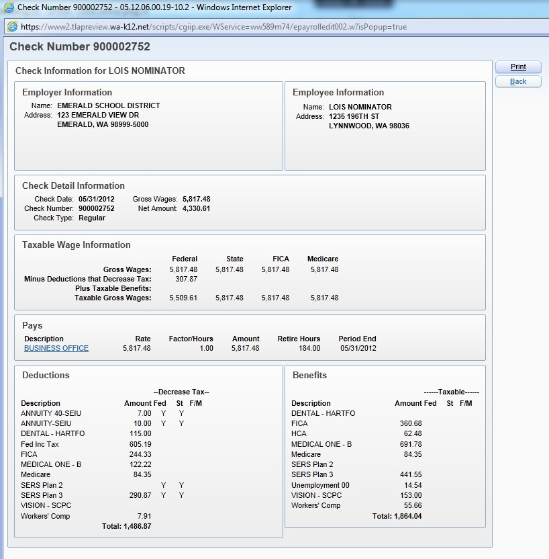

Net Amount = Gross Wages - Deductions

Total of non-taxable deductions.

Taxes for each column are calculated based on the Taxable Gross Wages amount.

All contracts and time sheet payments for the pay

period.

**Viewing Leave Balances**

Leave balances are updated in real time. As soon as they are entered into the system they will be reflected in your balances. If you feel that something was entered incorrectly please contact your supervisor. To view leave balances and activity, Click on the TIME OFF button, then the MY STATUS button.

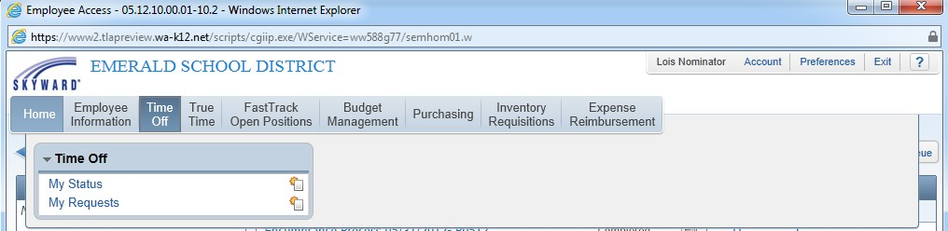

After you click on the MY STATUS button, you’ll see a screen like this, showing each category of leave available to you in the TIME OFF CODE column, how the total of leave accrued and awarded in the current year under the ALLOCATED column, leave used in the USED column, and leave balances remaining in the REMAINING column:

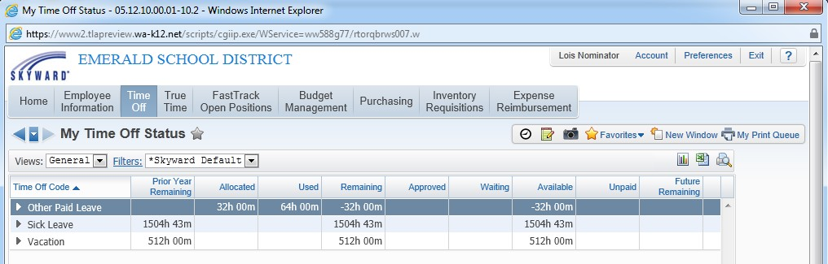

Besides each leave TIME OFF CODE name type there is a arrow pointing to the right. Clicking on the arrow besides each leave category in the TIME OFF CODE column shows leave transactions recorded to date (see screenshot on page 7).

**Viewing Personal Information**

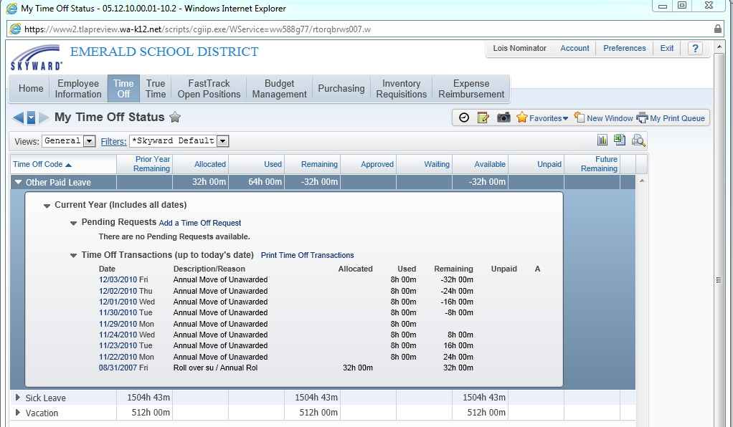

Personal Information such as Address and Phone may be verified using Employee Access. In addition to viewing check information, you may run payroll reports on user-specified periods of time. You may also change your Employee Access password.

***Viewing Address and Phone Information***

Click on the EMPLOYEE INFORMATION then PERSONAL INFORMATION:

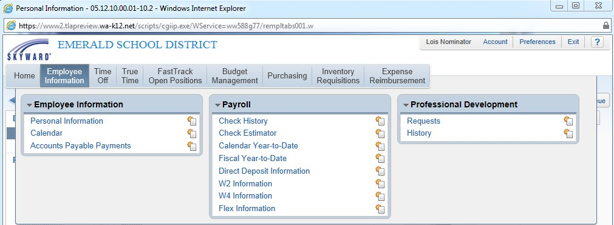

This screen will appear:



_ Personal Information - 05.12.10.0().01-102 - Windows Internet Explorer

((fu R o·

EMERALD SCHOOL DISTRICT

LOtS Nominator Account Preferences Exrt

Home

Time

Off

True

Time

FastTrack

Open Positions

Budget

Management

Purchasing

Inventory

Requisitions

Expense

Reimbursement

Personal Information 1t 

Demographci

Employee Info

Address

Personnel

Employee: NOMINATOR LOIS

Employee Info

*r*

)(oew

HiStory

s

PersonnelInfo

Lane!Step History

Employee Information

*Click here to request*

Assignments t

*Employee*

Prof Development

Certifications

Payroll

Checks

Check Estimator Calendar YTD FiscalYTD History Report Direct Depos

W2 Information

Name

Former Name:

Spouse Name: Phone

Phone 1: (

Phone 2: (

Ext: Ext:

Request

Ch n

Cont. No No

Coni. No

No

*Information*

*chanf:es.*

W4 Information Flex Information Time Off Status Insurance

Sub Transactions

AP Payments

Time Off Org Chart

UDF Tables

Calendar Year Benefits

Contact

FOOD HANDLERS PEF TEST

Attachments

Reports

My Own Info

Web Post

Phone 3: ( Ext: No

Emal: LO SNOMINATOR@@ esd.bog

Race and Ethnicity

Ethmaty: r Hispamc/Labno?

FederalRace: r 1-Amencan Indoan or Alaskan Native

r 2-Aslan

r 3-Biad< or African American

r 4-Nabve Hawaooan or Other PaaficIslander

r 5-Whrte

***Running Payroll Reports***

Employee Access allows users to run specific reports on their payroll information. To view and or run payroll reports available to you, select EMPLOYEE INFORMATION >PERSONAL INFORMATION (shown on page 8). Then click on MY OWN INFO under Reports (see screenshot below).

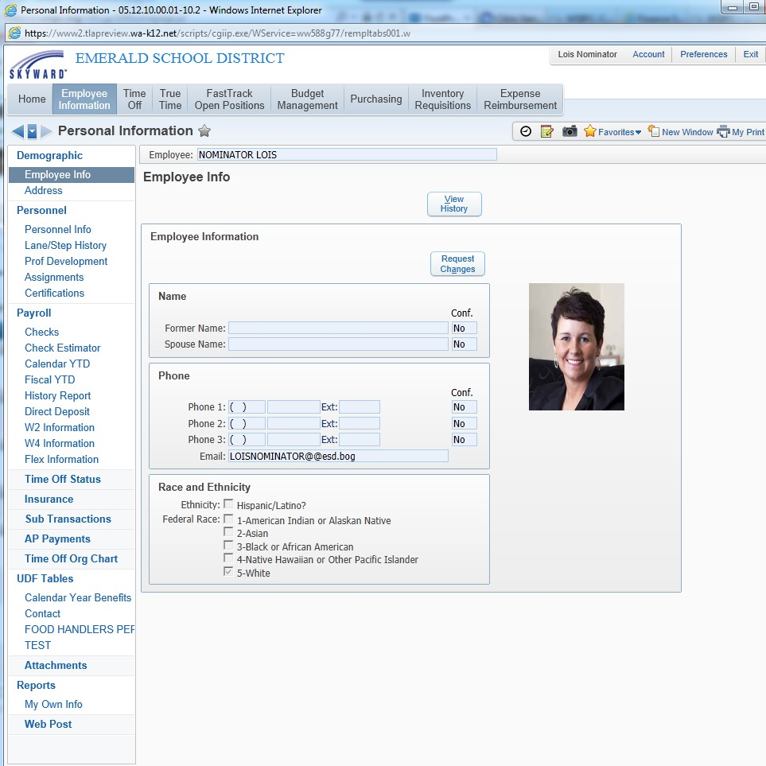

The Report Options Screen allows you to select the report you want to run. Highlight the desired report by single clicking on it. Then hit PRINT (see screenshot on next page). The report will run.

**Using the Check Estimator**

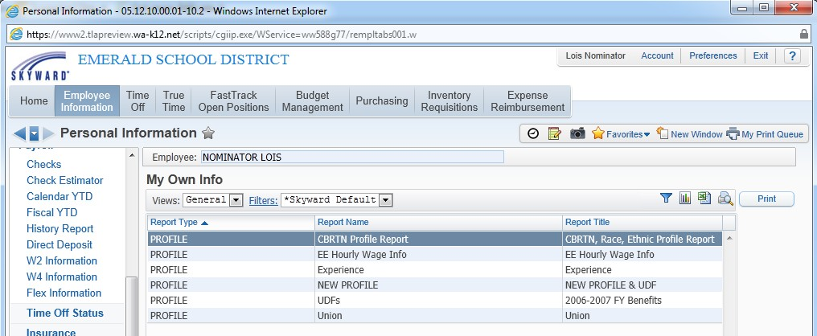

If you would like to see what your check looks like with different deductions, you can use the Check Estimator. Go to EMPLOYEE INFORMATION> PERSONAL INFORMATION > CHECK ESTIMATOR. ***Please note: this will not change your payroll. This feature is informational only.***

The first screen (shown on page 11) enables you to make changes to withholding status and pay rate information. When finished entering the changes you wish to calculate on the first screen, select the ***Continue Check Estimator Process*** button. Make sure that at least one of the pay types is selected or the estimator will not work.

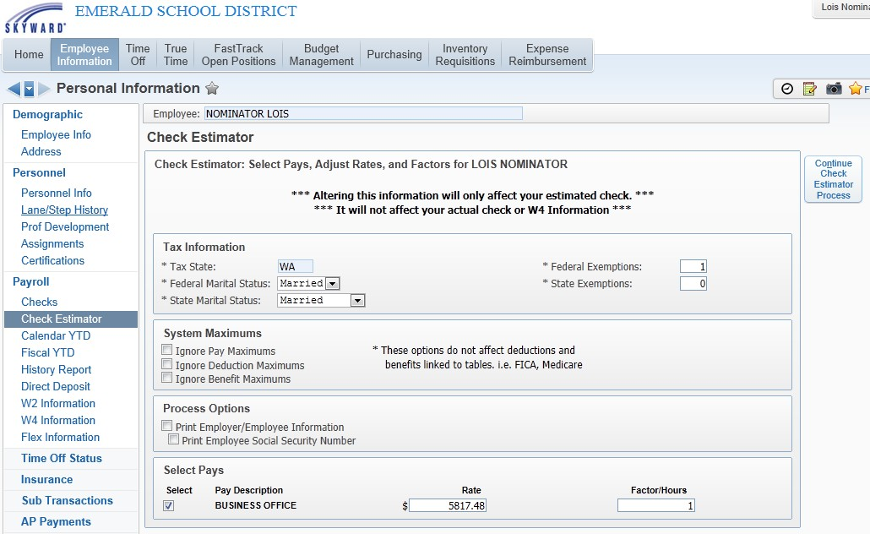

The second screen allows the user to adjust the deductions and benefits of each payroll assignment. Once all deduction/benefit changes have been made, click on the Calculate Check to complete the Check Estimator Process.

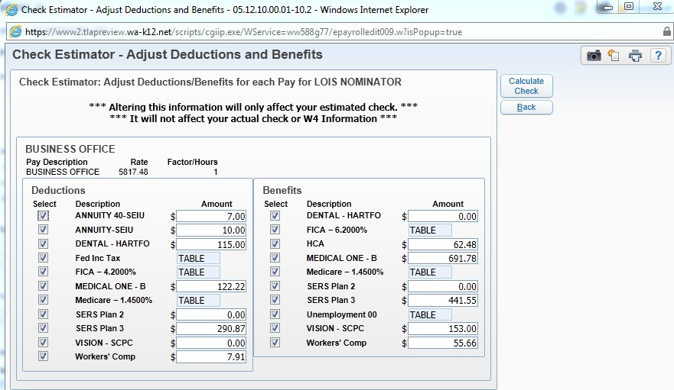

***Note: This process does not make changes to your payroll.***

**Verify your W-4 information**

Employee Access enables you to view the withholding status from your W-4 form.

***The information in this area is informational. If you want to make a change, you will need to contact payroll.***

Go to EMPLOYEE INFORMATION> PERSONAL INFORMATION>PAYROLL > W4

INFORMATION

From here you will be able to view the information currently being used by payroll to calculate your federal withholding. Click on SHOW W4 Info (see screenshot on page 13).

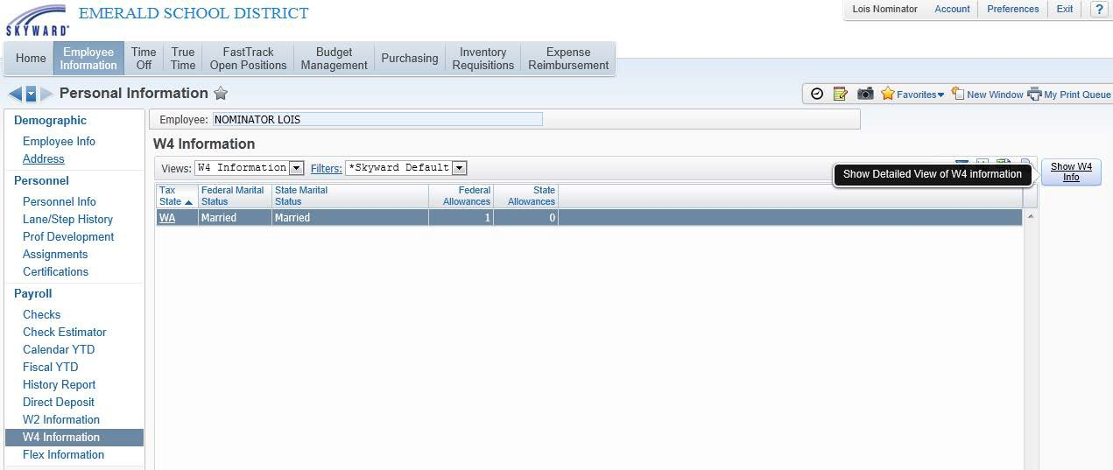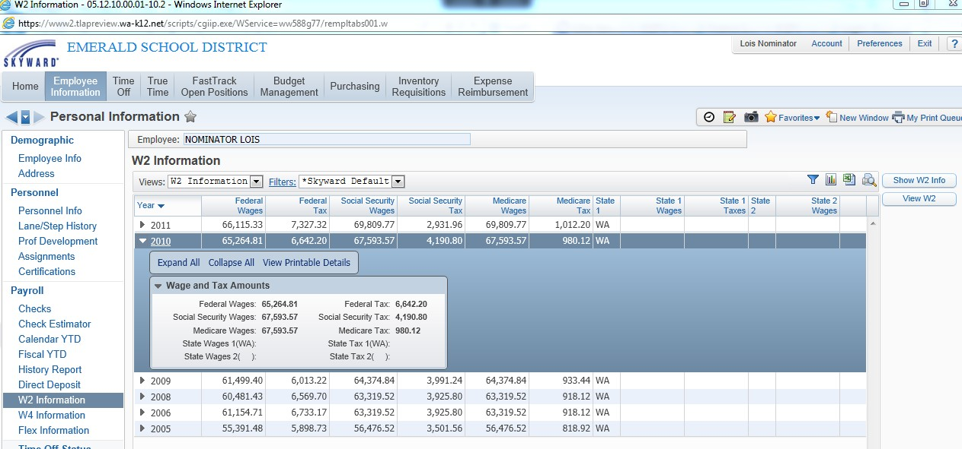

**Viewing and Printing W-2**

Employee Access enables you to view and print your W2 information. Go to EMPLOYEE INFORMATION>PERSONAL INFORMATION> PAYROLL > W2 INFORMATION.

Select the year you would like to view by clicking on the arrow to the left of the year. A box will appear that explains how the information on your W2 is calculated. To print an actual W2, use your mouse to select the desired year and select the View W2 button on the right. Your W2 will be displayed in PDF format which you can then print and use for filing your taxes.

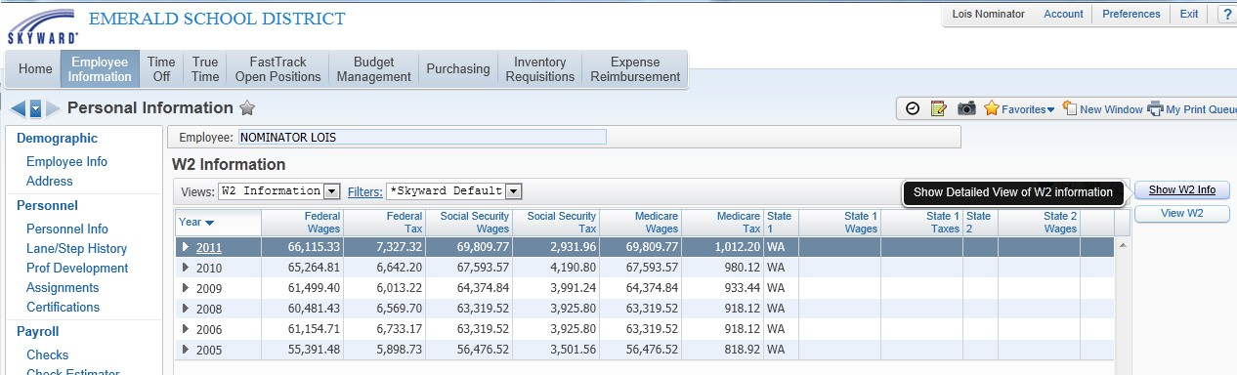

To print an actual W2, use your mouse to highlight the desired year, then click the View W2 button on the right. If you want to view how your W2 Information is calculated, click on the SHOW W2 INFO button. Your W2 and “Show W2 Info” report will be displayed in PDF format and can be printed.